Name: Muhammad Uzair

Roll No. L1F18BSCS0311

Section - H

Database

Lab 12

Task 1

select \* from customers

where exists(select orders.customernumber from orders

where customers.customernumber = orders.customernumber

and orders.status = 'Cancelled'

and year(shippedDate) = '2003');



Task 2

select employees.email from employees

where employees.jobTitle = 'Sales Rep' and exists(select offices.officeCode from offices

where offices.officeCode = employees.officeCode

and offices.country = 'France' or offices.country = 'Japan');

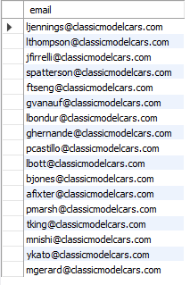

Task 3

select customers.postalCode from customers

where exists (select payments.customerNumber from payments

where payments.customerNumber = customers.customerNumber

and payments.amount > 1000 and payments.amount < 4000

and exists(select orders.customerNumber from orders where customers.customerNumber = orders.customerNumber

and orders.status = 'Shipped'));

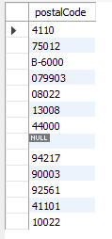

Task 4

select products.productName from products

where exists(select orderDetails.productCode from orderDetails

where orderDetails.productCode = products.productCode

and orderDetails.quantityOrdered between 30 and 50

and products.productLine = 'Classic Cars');

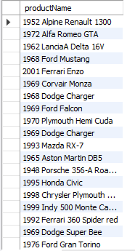

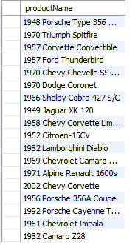

Task 5

select customerName, creditLimit from customers

where customerName like 'A%' and exists(select orders.customerNumber from orders

where orders.customerNumber = customers.customerNumber

and year(orderDate) = '2003'

and exists(select orderNumber from orderDetails

where orders.orderNumber = orderDetails.orderNumber

and quantityOrdered > 50));

